**EXPLORE THE WORLD WITH**

**SHEAFE’S FLAT BLUEBIRD**

STUDENT NAME: ___________________________________________ ROOM _____________

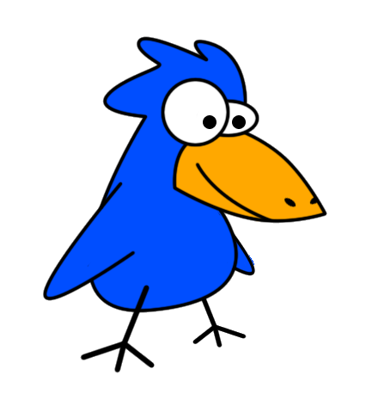

Hi Kids! Come fly with me as I travel around the world. We’re going to visit lots of great places while we learn lots of new things! This month we will be visiting:

**AUSTRALIA**

G’day Mate! We’re glad you decided to stay with us for a bit. Now that you’ve learned about the Great Barrier Reef and some of Australia’s aquatic animals, let’s shift our focus to two o our most famous animals, the Kangaroo and the Kola. Both the kangaroo and kola are marsupials.

Marsupials are members of the mammal family. However, they are different from other mammals because they have an abdominal pouch to carry their young. The marsupial female gives birth very early and the baby animal climbs from the mother's birth canal to her pouch. Here the baby marsupial continues to develop for weeks, or even months.

At birth, marsupial babies are not fully developed so they live and continue to develop in their mommy’s pouch. The pouch has everything the mommy needs to feed the baby.

Below are two pictures, your challenge to identify the animal in each picture and then color it.

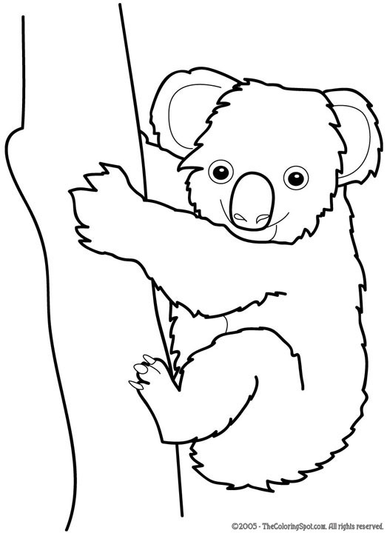 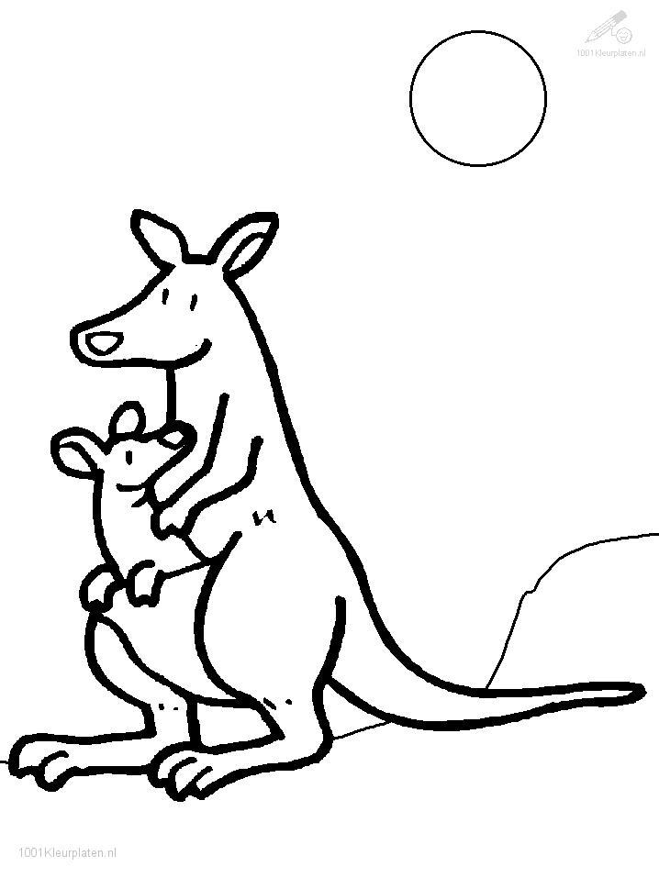

For an additional challenge, complete this double-bubble map: (hint: the middle bubble are characteristics that both animals share and then outer bubbles are unique characteristics to each animal).

KANGAROO

KOALA